ECE-1000 Final Project: Simon Says Game

Report

Asher Owens, Hayden Hobgood

Tennessee Tech University

12/3/2024

*Abstract*

I chose this project because I have always liked playing Simon Says. In this project you get to use a good blend of circuitry and coding. The physical circuit intrigues me more so we chose the one we thought would have the best blend. The object of the project is to create a circuit with RGB LEDs, LCD Screen, Buttons, and a Buzzer connected to a Raspberry Pi Pico in order to create a Simon Says game. I worked on the RGB LEDS and the Buttons coding to make the sequence and the main chunk of the game. First, I created a tinker cad schematic to understand how cathode RGB LEDs worked. I then applied that new knowledge onto the breadboard. I was able to create four different colors by using two pins on the last LED to make purple. We chose purple for the fourth color to show the most distinction against all the other LEDs. The coding was simple. I used an example code given from a more simplistic game. This one only used one LED but did the sequence on the one. The code defines all the pins for the LEDs under led pin. Then we do the same for the button pins but also naming them in alignment with Leds on the board. The first RGB from left to right is connected to the first LED. The main code is a while loop that uses the append ability to keep adding onto the sequence. This allows the sequence to get harder and harder as the user plays. This then calls the print function which lights the correct LEDs in a sequence. Once the user sees the sequence they are allowed to follow with their inputs. If the inputs are right score is increased, and the sequence is appended. If the user is wrong, it sets the score to 0, turns off all the RGBs, and then ends the program.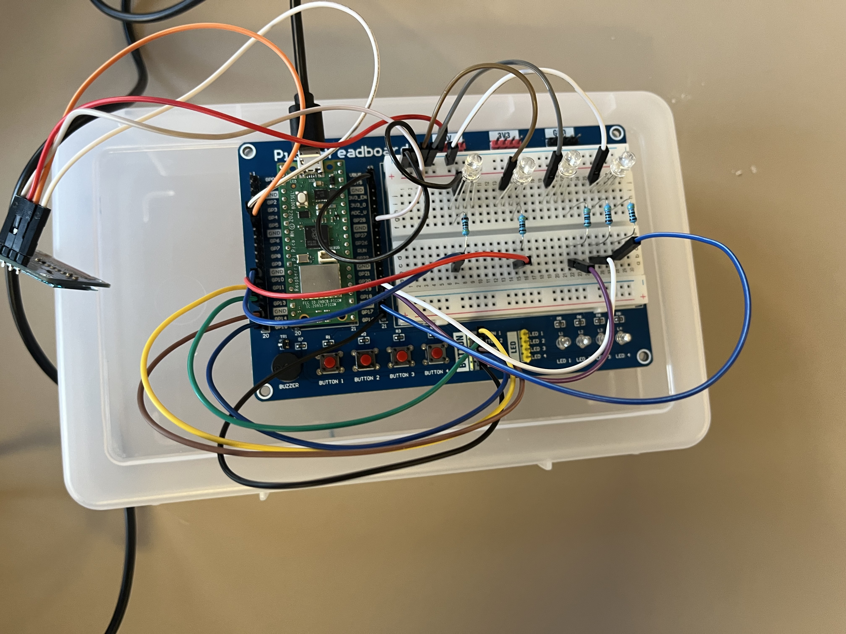

*Fig 1 finished circuit with all connections*

*Index*

Appendix, Table Contents, Pin Placement Chart, Intro, Methodology, Implementation steps, Conclusion

PIN PLACEMENT

|  |  |  |
| --- | --- | --- |
| GPIO 10 | LED | Red |
| GPIO 11 | LED | Green |
| GPIO 18 | LED | Blue |
| GPIO 19 | LED | Purple(red) |
| GPIO 17 | LED | Purple(blue) |
| GPIO 12 | Button 1 | #1(for red LED) |
| GPIO 13 | Button 2 | #2(for green LED) |
| GPIO 14 | Button 3 | #3(for blue LED) |
| GPIO 15 | Button 4 | #4(for purple Led) |

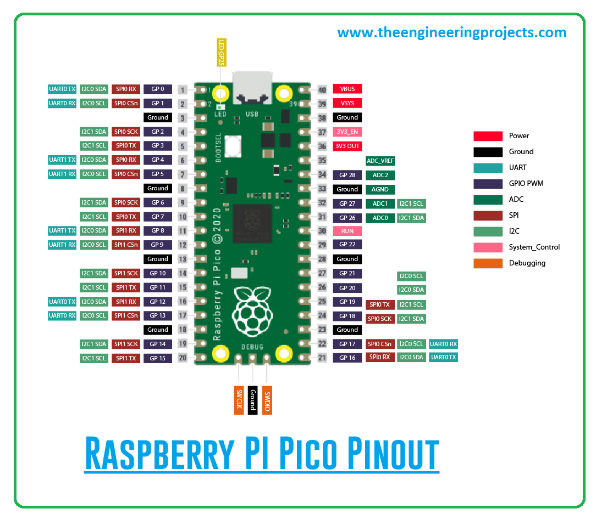

*Fig 2. Raspberry Pi Pico Pinout*

*Intro*

The Simon Says game is a memory challenge that helps improve cognitive skills. This project uses a Raspberry Pi Pico to create an interactive version of the game, providing a customizable, educational tool for children to develop their memory and concentration.

Some kids do not have the financial income to buy newer games which have proven to develop memory and concentration. This is a good way to make an easy and cheap game.

*Objective*

* Design a Simon Says game using Raspberry Pi Pico.
* Display color patterns with RGB LEDs.
* Allow players to replicate the patterns by pressing buttons.
* Provide feedback with sound effects (success/error).
* Display the score and level on an LCD screen.
* Increase difficulty with longer patterns.

What it covers: Designing and building a game using Raspberry Pi Pico, RGB LEDs, buttons, buzzers, and an LCD screen.

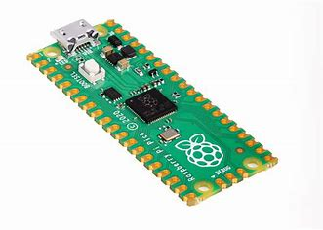

*Fig 3. Raspberry Pi Pico Board*

Limitations: The game will focus on color patterns with basic functionality, without advanced features like multiplayer or time-based challenges.

*Methodology*

*Materials and Tools*

* Raspberry Pi Pico (for processing and control)
* 4 Cathode RGB LEDs (to display color sequences)
* Push Buttons (for user input)
* Buzzer (for feedback sounds)
* LCD Screen (for score display)
* Jumper Wires
* Bread Board

Software

* Micro Python
* Tinker Cad

Implementation Steps

Setup Hardware: Connect the RGB LEDs, buttons, buzzer, and LCD screen to the Raspberry Pi Pico following the appropriate wiring guides.

*Code Development:*

* Write a Micro Python script to control the LEDs, buttons, and buzzer.
* Implement pattern generation, where the sequence is displayed on the RGB LEDs.
* Capture user input through the buttons and validate if the pattern is replicated correctly.
* Append the pattern and increase its length after each correct input.
* Display the score and current level on the LCD screen.
* Provide auditory feedback (correct or error sounds) through the buzzer.

*Testing and Debugging:*

Test the system for accuracy in pattern recognition and ensure the feedback functions correctly.

Did the project meet its goals? Yes, the project successfully met its goals. The Simon Says game, powered by the Raspberry Pi Pico, functions as intended. The system generates a sequence of colors on the RGB LEDs, allows the user to input the sequence using the buttons, provides feedback through a buzzer, and displays the score on an LCD screen. The game increases in difficulty by progressively adding colors to the sequence, making it both engaging and challenging for the player.

*Challenges faced during development:*

One of the main challenges was ensuring the pattern recognition system was both responsive and accurate. There were also issues with handling the RGB LEDs, as controlling multiple colors at once required precise timing and coding to avoid visual inconsistencies. Debugging the button inputs to reliably detect the correct sequence required careful consideration of debounce logic to avoid false readings.

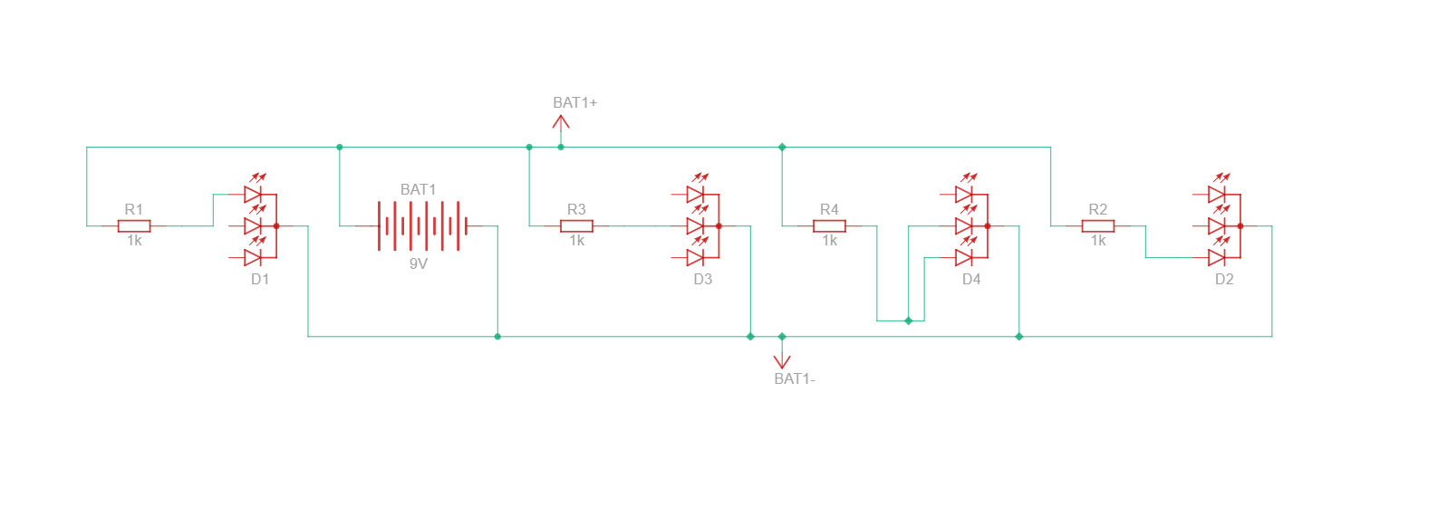

*Fig 2. Tinker Cad RGB LED Schematic*

*Insights gained and implications:*

This project demonstrated how accessible and customizable embedded systems can be using the Raspberry Pi Pico and Micro Python. It showed that even simple hardware can create an engaging and educational tool. The hands-on nature of the project reinforced the importance of understanding both hardware and software integration in creating interactive devices.

*Shortcomings or unexpected findings:*

One limitation was the need for physical interaction (button presses) which can become tedious for extended gameplay. In addition, the project doesn’t include advanced difficulty settings such as timed challenges or multiplayer options, which could have made the game more dynamic. The lack of a visual timer or feedback system for the user’s performance may limit the overall user experience.

*Conclusion*

The main objective was to develop a Simon Says game using Raspberry Pi Pico. The game successfully displays color patterns, accepts user input, provides feedback, and tracks the score, meeting the original goals. The project demonstrated the effectiveness of using the Raspberry Pi Pico as a central processing unit for an interactive game.

This project contributes to the understanding of embedded systems by combining simple electronics and software to create an interactive game. It showcases practical use cases for RGB LEDs, buttons, buzzers, and LCD screens in developing educational tools.

*Future improvements could include:*

* Adding a timer feature to increase the challenge.
* Implementing multiplayer support for competitive play.
* Introducing a more sophisticated feedback system, such as visual cues or adaptive difficulty.
* Using more advanced components like capacitive touch sensors or mobile app integration to make the game more interactive.

Works Cited

Tom's Hardware. "How to Make a Simon Game with Raspberry Pi Pico." *Tom's Hardware*, <https://www.tomshardware.com/how-to/make-simon-game-with-raspberry-pi-pico>, Accessed 3 December 2024.

Tinker cad. "Getting Started with Tinker cad." *Tinker cad*, <https://www.tinkercad.com/learn>, Accessed 3 December 2024.

ChatGPT. "Assistance with Simon Says Game using Raspberry Pi Pico." *OpenAI*, Accessed 3 December 2024.